MATERIAL SUPLEMENTARIO

MST1
Promedio y desviación estándar de las especies Corollia perspicillata, Corollia castanea y Corollia brevicauda con las variables (cola, pata, antebrazo, pata, tibia, calcar, trago y tamaño corporal) de las hembras y machos
SMT1
Mean and standard deviation of the species Corollia perspicillata, Corollia castanea and Corollia brevicauda with the variables (tail, leg, forearm, paw, tibia, calcar, tragus and body size) of females and males
Variables |  | Carollia brevicauda |  |  |  | - castanea |  |  |  | - perspicillata
 |  | Hembra |  | Macho |  | Hembra |  | Macho |  | Hembra |  | Macho
 |  | Media | SD | Media | SD | Media | SD | Media | SD | Media | SD | Media | SD
Adultos | Calcar | 6.52 | 1.47 | 6.39 | 1.22 | 4.94 | 1.58 | 5.42 | 1.26 | 6.07 | 1.48 | 6.34 | 1.42
Adultos | Cuerpo | 60.00 | 5.67 | 58.67 | 4.00 | 53.36 | 6.25 | 54.23 | 5.27 | 58.36 | 6.87 | 59.51 | 5.38
Adultos | Antebrazo | 40.78 | 3.45 | 41.42 | 2.14 | 37.67 | 3.59 | 38.06 | 2.63 | 41.27 | 2.08 | 42.16 | 1.70
Adultos | Cola | 7.66 | 0.73 | 7.48 | 0.57 | 7.39 | 0.70 | 7.35 | 0.61 | 9.23 | 0.72 | 9.26 | 0.71
Adultos | Oreja | 16.18 | 2.05 | 15.67 | 2.03 | 15.09 | 2.21 | 15.21 | 2.47 | 15.11 | 2.75 | 14.55 | 2.65
Adultos | Pata | 10.48 | 1.36 | 10.51 | 1.64 | 10.72 | 2.12 | 10.44 | 1.66 | 10.96 | 2.34 | 11.44 | 2.44
Adultos | Tibia | 18.22 | 1.39 | 18.42 | 1.17 | 15.72 | 2.00 | 16.21 | 2.09 | 17.87 | 2.12 | 18.20 | 2.29
Adultos | Trago | 4.70 | 0.89 | 4.82 | 1.04 | 4.72 | 0.98 | 4.81 | 0.96 | 4.23 | 1.12 | 4.51 | 1.02
Juveniles | Calcar | 5.67 | 1.53 | 8.33 | 0.58 | 3.00 | 0.00 | 4.25 | 1.26 | 5.75 | 1.49 | 6.00 | 1.53
Juveniles | Cuerpo | 53.00 | 5.29 | 59.33 | 1.53 | 45.00 | 0.00 | 46.00 | 3.56 | 58.62 | 5.60 | 57.29 | 5.19
Juveniles | Antebrazo | 37.67 | 3.51 | 43.33 | 3.21 | 34.00 | 0.00 | 35.25 | 4.72 | 42.00 | 1.60 | 41.43 | 1.28
Juveniles | Cola | 8.00 | 1.00 | 7.67 | 0.58 | 7.00 | 0.00 | 8.00 | 1.15 | 9.87 | 1.55 | 9.00 | 0.00
Juveniles | Oreja | 13.33 | 1.53 | 14.67 | 2.31 | 19.00 | 0.00 | 14.00 | 2.45 | 14.25 | 3.10 | 14.00 | 2.31
Juveniles | Pata | 11.33 | 0.58 | 10.33 | 2.89 | 11.00 | 0.00 | 10.5 | 1.91 | 13.24 | 2.05 | 11.14 | 2.03
Juveniles | Tibia | 17.33 | 0.58 | 18.00 | 0.00 | 12.00 | 0.00 | 14.75 | 1.71 | 18.12 | 3.64 | 18.00 | 2.94
Juveniles | Trago | 3.33 | 1.53 | 4.67 | 0.58 | 5.00 | 0.00 | 4.75 | 0.50 | 4.37 | 1.06 | 4.00 | 1.15
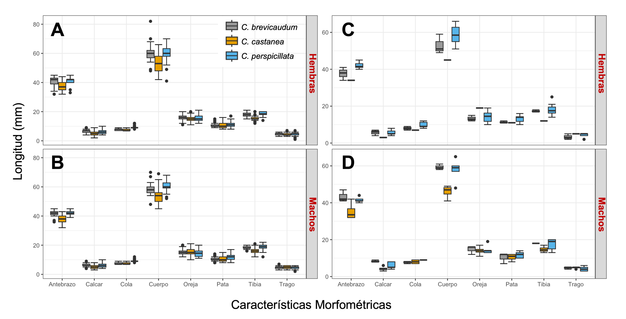
MSF1. Comparación de variables morfométricas externas de adultos. A.-B. Jóvenes. C.-D. Entre Carollia perspicillata, Corollia castanea y Corollia brevicauda.
SMF1. Comparison of external morphometric variables of adults A.-B. Juveniles. C.-D. Between Carollia perspicillata, Corollia castanea and Corollia brevicauda.
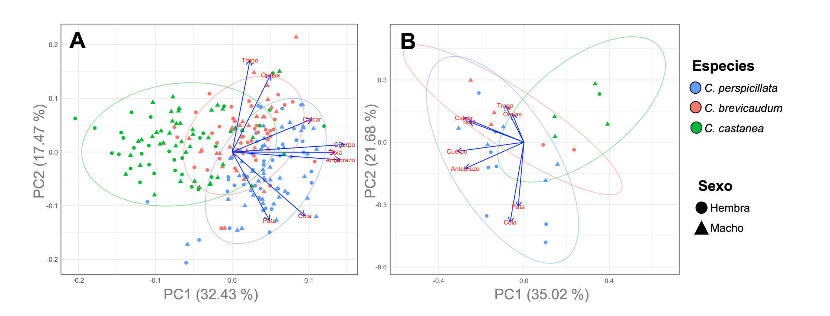
MSF2. Análisis de componentes principales de las características morfométricas externas con agrupación mediante clústeres por especies. A. Adultos. B. Juveniles.
SMF2. Principal component analysis of external morphometric characteristics with clustering by species. A. Adults. B. Juveniles.

